AI ASSISTED LAB ASSIGNMENT – 3.1

Prompt Engineering

Name: G.Narasimha reddy

2503A52400

Batch 14

Task-1: Zero-Shot Prompting (Palindrome Number Program)

Input:

# generate a Python function that checks whether a given number is a
palindrome.

def is_palindrome(number):
"""Return True if an integer reads the same forwards and backwards."""
if not isinstance(number, int) or isinstance(number, bool):
raise TypeError("number must be an integer")
if number < 0:
return False
return str(number) == str(number)[::-1]

# Tests with multiple inputs.
test_inputs = [0, 1, 121, 12321, 123, 10, -121, 1001]
for value in test_inputs:
print(f"{value}: {is_palindrome(value)}")

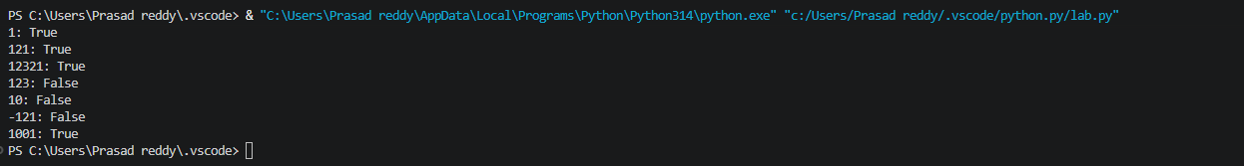

:

Task-2:One-Shot Prompting (Factorial Calculation)

Input:
# generate a Python function to compute the factorial of a given number.
# Code generated from the one-shot prompt:
def factorial_one_shot(n):
"""Return n! for a non-negative integer n."""
if not isinstance(n, int) or isinstance(n, bool) or n < 0:
raise ValueError("n must be a non-negative integer")

result = 1
for value in range(2, n + 1):
result *= value
return result

# Typical code generated by a zero-shot request:
def factorial_zero_shot(n):
"""Return n! using recursion."""
if n == 0:
return 1
return n * factorial_zero_shot(n - 1)

def show_outputs():
test_values = [0, 5, 7]
print("One-shot prompt:")
print("\nOutputs:")
for number in test_values:
print(
f"Input: {number} -> "
f"One-shot: {factorial_one_shot(number)}, "
f"Zero-shot: {factorial_zero_shot(number)}"
)

print("\nComparison:")
print("- Clarity: The one-shot version documents the expected input and output.")
print("- Correctness: It handles 0 and rejects negative, non-integer, and boolean input.")
print("- The zero-shot version works for basic non-negative integers, but has less validation")
print(" and may hit Python's recursion limit for large values.")

if __name__ == "__main__":
show_outputs()

Output:
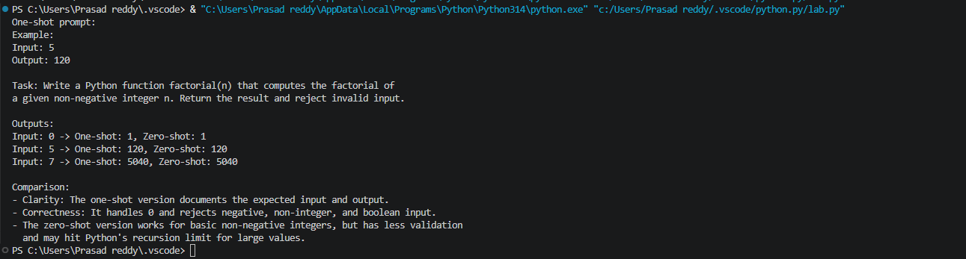

Task-3: Few-Shot Prompting (Armstrong NumberCheck)

Input:

# generating a Python function to check whether a given number is an Armstrong number.

def is_armstrong(number):
"""Return True if number is an Armstrong number."""
if number < 0:
return False

digits = str(number)
power = len(digits)
return sum(int(digit) ** power for digit in digits) == number

number = int(input("Enter a number: "))
if is_armstrong(number):
print(f"{number} is an Armstrong number.")
else:
print(f"{number} is not an Armstrong number.")

Output:
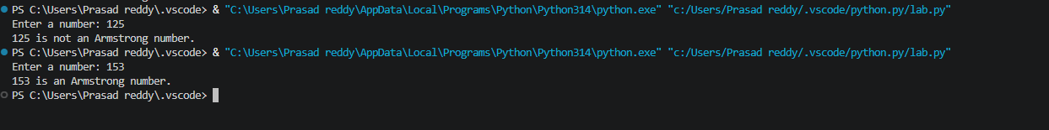

Task-4: Context-Managed Prompting (Optimized Number
Classification)

Input:

#generate an optimized Python program that classifies a
number as prime, composite, or neither

from contextlib import contextmanager
from math import isqrt

@contextmanager
def classification_prompt():
"""Apply clear instructions and constraints while creating the solution."""
instructions = {
"task": "Classify an integer as prime, composite, or neither.",
"constraints": (
"Validate input, handle negatives and non-integers, and test divisors "
"only through the square root."
),
}
try:
yield instructions
finally:
instructions.clear() # End the prompt context cleanly.

def classify_number(value):
"""Return the classification of an integer."""
if isinstance(value, bool) or not isinstance(value, int):
raise ValueError("input must be an integer")
if value < 2:
return "neither"
if value == 2:
return "prime"
if value % 2 == 0:
return "composite"
for divisor in range(3, isqrt(value) + 1, 2):
if value % divisor == 0:
return "composite"
return "prime"

def classify_input(text):
"""Validate text input and classify its integer value."""
try:
number = int(text.strip())
except (AttributeError, ValueError):
return "invalid input (enter an integer)"
return classify_number(number)

def main():
with classification_prompt() as prompt:
print("Prompt constraints:", prompt["constraints"])

print("Optimized outputs:")
for value in ("1", "2", "17", "18", "49", "-3", "abc"):
print(f"{value!r} -> {classify_input(value)}")

print("\nComparison with earlier strategies:")
print("- Basic trial division: checks every divisor up to n; slower for large n.")
print("- Optimized context-managed solution: validates input and checks odd divisors only to √n.")
print("- Result: same classifications, with fewer checks and explicit invalid-input handling.")

if __name__ == "__main__":
main()

Output:

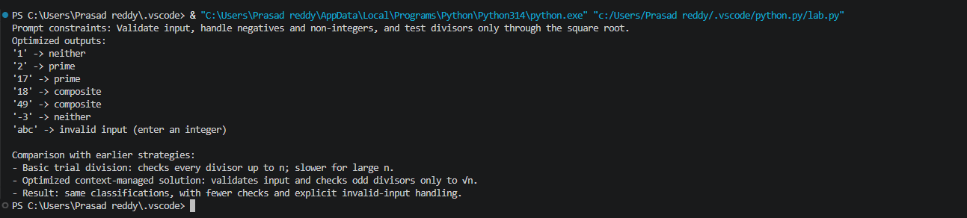

Task-5: Zero-Shot Prompting (Perfect Number Check)

Input:

# generate a Python function that checks whether a given number is a

perfect number.

def is_perfect_number(number):
"""Return True if number equals the sum of its positive proper divisors."""
if not isinstance(number, int) or isinstance(number, bool) or number <= 1:
return False

divisor_sum = 1
divisor = 2
while divisor * divisor <= number:
if number % divisor == 0:
divisor_sum += divisor
paired_divisor = number // divisor
if paired_divisor != divisor:
divisor_sum += paired_divisor
divisor += 1
return divisor_sum == number

# Test the program with multiple inputs.
test_inputs = [1, 2, 6, 28, 12, 496, 8128, 0, -6, 7]
print("Test outputs:")
for value in test_inputs:
print(f"{value}: {is_perfect_number(value)}")

Output:
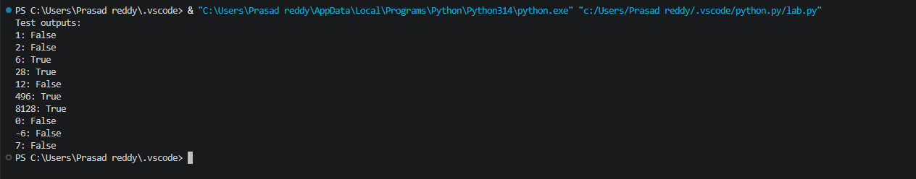

Task-6: Few-Shot Prompting (Even or Odd Classification with

Validation)

Input:
# generating a Python program that determines whether a given number is even or odd, including proper input validation.

def classify_number(value):
"""Return Even/Odd for an integer, or an error message for invalid input."""
value = value.strip()
if not value:
return "Invalid input: enter an integer."

try:
number = int(value)
except ValueError:
return "Invalid input: enter an integer."

# Reject values such as "3.0" while accepting signed integers.
if str(number) != value.lstrip("+") and not (
value.startswith("-") and str(number) == value
):
return "Invalid input: enter an integer."

return "Even" if number % 2 == 0 else "Odd"

if __name__ == "__main__":
user_input = input("Enter a number: ")
print(classify_number(user_input))

Output:
